Reverse Event Planning Guide

A Reverse event is when students distribute tickets to any staff member. Reverse events are a powerful experience for both students and staff. A reverse event can:

- Provide staff with the experience of receiving a ticket.
- Boost staff morale.
- Contribute to positive school climate.
- Provide students with an opportunity to learn how to give a compliment.
- Reinforce students’ understanding of the school norms.

View a Video from School #11, Clifton Public Schools
Emma Havens Young Reverse Day and Booster Week Plan

Materials you will need:
- A schedule that organizes the event
- An electronic or paper ‘ticket’ for staff
- Announcement scripts

Reverse Day (Week) Action Plan

Get Ready for the Event | Who? | By When? | Notes, Links, etc.
DATES
- Select the week and dates during which your Reverse event will occur
STUDENT INSTRUCTION
- Develop a brief instructional plan for teaching students what the reverse event is and how to distribute tickets to staff
TEASER ANNOUNCEMENTS
- Prepare an announcement script (see below for examples) for the week before previewing the event that you will use over the PA system
- Prepare social media posts about the event
PAPER OR ELECTRONIC TICKET
- Decide if you will use a paper or electronic ticket
- Logistically, tickets are more involved to coordinate (copying, distributing etc.), but are more powerful tokens because of the in-person exchange that occurs
- An electronic ticket can make the logistics easier in a large school or with older students, but it lacks some of the magic that occurs when a student engages the staff member to give them a ticket
PREPARE A PAPER STAFF TICKET
If using a paper ticket
- Decide what ticket will be used
- Determine who will copy, cut, and pack tickets to distribute to students (each student receives 3-5 tickets)
- Tickets are best collated int packs for each class (25 students = 25 packs of 3-5 tickets)
PREPARE THE ELECTRONIC TICKET
If using an electronic ticket
- Decide what electronic format you will use to represent the ‘ticket’ (e.g., Google form, jpeg image, etc.)
- Determine the procedure for how students recognize staff (e.g., each day students receive a link to a form they can use to nominate a staff person)
- Determine how you will share the nominations with staff
TICKET DISPLAY
- See picture samples below
- Will you develop a display with the tickets?
- If so, how will tickets be collected (e.g., bins)?
- What are the procedures for collecting the ticket?
- Where will the display go?
- Who will set up the display?
- Who will clean up the display?
- Remember to give staff their tickets after the display is dismantled
OTHER STAFF CELEBRATION
- Will you include any other staff celebrations during the event (e.g., hosting coffee and bagels or having a drawing for a gift)

During the Event | Who? | By When? | Notes, Links, etc.
DAILY ANNOUNCEMENTS
- Develop the announcements (see sample below)
MONITOR IMPLEMENTATION
- Have a way to determine that students are distributing tickets
- What will you do if you notice tickets are not being distributed?
Conclude the Event | Who? | By When? | Notes, Links, etc.
CONCLUSION ANNOUNCEMENT
- See example below
- Prepare an announcement that brings the reverse event to a close

Sample Schedule

- Thursday – Friday previous week
  - Reverse Event teaser announcements
- Monday – week of
  - Deliver a preview of the Reverse Event
- Tuesday
  - Start the day with a 10-minute instructional presentation on how to distribute tickets
  - Each student receives 3-5 tickets
- Tuesday – Thursday students distribute tickets
- Friday, conclude with a celebration
- Follow up: Staff deposit their tickets in a central location to be included in a display

Featured Sample Tickets

Emma Havens Young School | Dr. John Winslow Elementary School
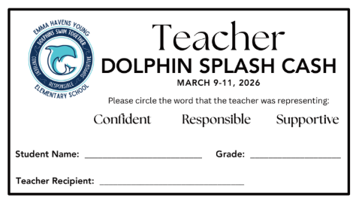 | 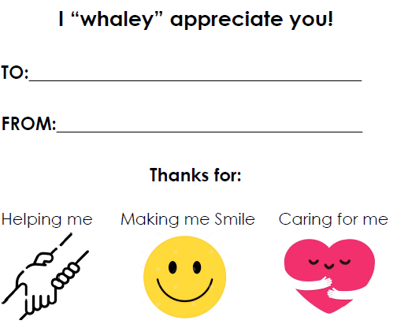

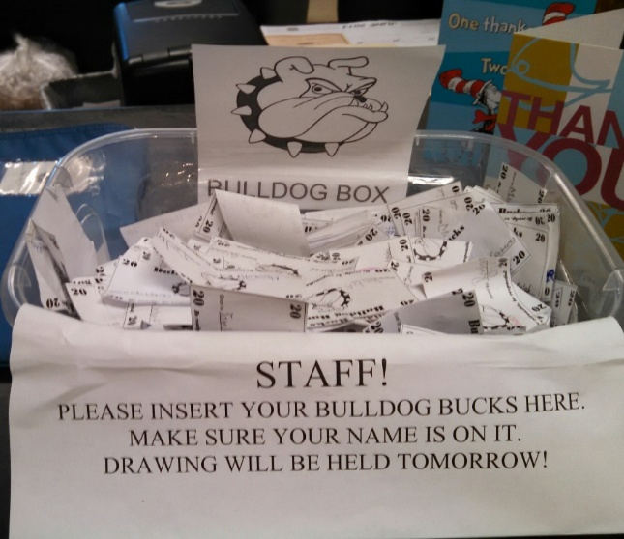

Sample Tickets and Displays

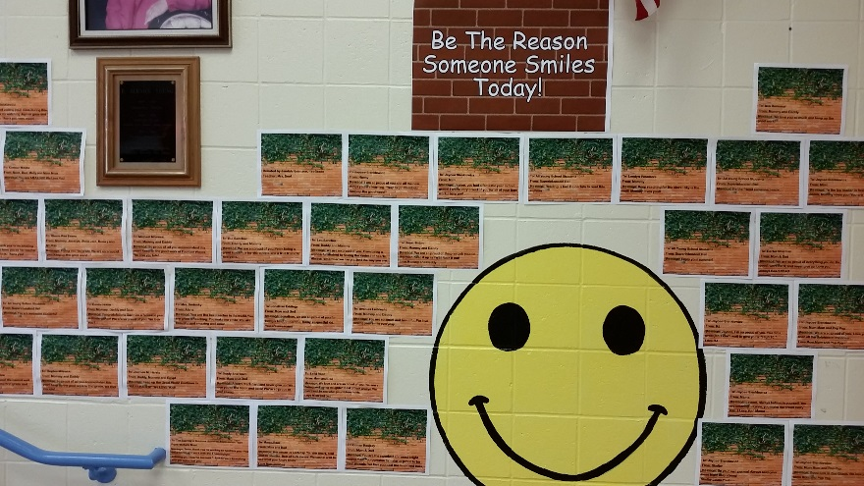 | 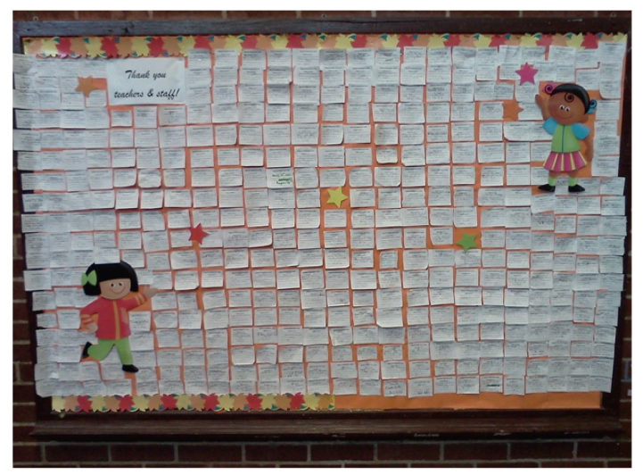

Sample Announcements
Friday, [date] Preview Announcement
‘Are you ready? Next week begins our reverse event. What is a reverse event? A reverse event is when the students, give the adults tickets for following the school norms. You’ll learn more our reverse event on Monday. In the meantime, think about the school norms and all the adults you see in a school day. Who would you like to give a ticket? Your teachers, the cafeteria monitors, the custodians, the secretaries? It’s going to be a lot of fun!’

Monday, [date] Extended Homeroom
Announcement. ‘It’s here! Today starts our reverse week event. In a few minutes your teacher is going to explain how the reverse week works and provide you with 5 tickets that you can use Monday, Tuesday, Wednesday, and Thursday. Reverse week is an opportunity to say thank you to the adults that help you when you have a problem, encourage you to keep going, celebrate your accomplishments, teach you new.

Brief Instruction: Homeroom teachers deliver a 15-minute instructional presentation (insert link to presentation)
- Review each school norms
- Give examples of actions adults do that are consistent with the norms
- Ask students to give adult examples of the norms
- Teach the ‘compliment script’
  - What is a compliment (A compliment is a type of thank you by which we acknowledge something positive about another person or something they did)
  - Why do we give a compliment (to provide others with encouragement)
  - What do we say when we give a compliment (Thank you for helping me with my assignment. I was really stuck and you helped me to move forward’)
- Review the procedures for distributing tickets
- Provide each student with their ticket packet.

Tuesday, (date) Announcement
‘The buzz in on! We’re hearing about staff receiving [reverse ticket name]. Shout outs to (name three – five staff that have received tickets. Let’s keep going! Plan to tell teachers and other classroom staff how they help you to be a scholar. If you were absent yesterday, you may pick up your tickets from your homeroom teacher.

Wednesday, (date) Announcement
‘It’s day 3 of our reverse and today we are celebrating all the adults who keep the school clean and orderly. Thank you [custodian[, [secretaries], [safety personnel]. We could not make this school great without you. Students use a ticket to thank our facility staff for all they do for us every day of the year.’

Thursday, (date)
‘It has been a fun and rewarding week. Our students are amazing! Our staff our amazing! Today is a great day to be at [name of school]. Stay tuned for our reverse week display’

