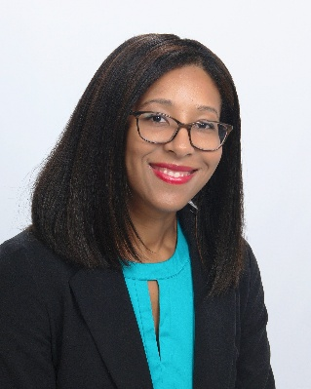 | Stephanie Michael, LMSW  Training and Consultation Specialist

Stephanie Michael, LMSW, is a Training and Consultation Specialist at The Boggs Center on Disability and Human Development. She provides training and technical assistance to schools involved in the NJ Positive Behavior Support in Schools project, a partnership between the New Jersey State Department of Education, Office of Special Education Programs, and The Boggs Center.

Stephanie has a passion for prevention and advancing systems change, specifically around empowering youth and families. She has had the privilege of collaborating on multiple grant-funded initiatives, including Enhancing School Mental Health (ESMH), Parent Education Technical Assistance (PETA), and County Councils for Young Children (CCYC). In these roles, she supported the delivery of training and technical assistance to educators, administrators, and parents to promote mental health, positive student behavior, conduct and social-emotional wellness, and greater childhoods; engaged and built alliances among internal agency and external community stakeholders; and created and distributed tools to evaluate project implementation fidelity.

Stephanie is a New Jersey Leadership Education in Neurodevelopmental and Related Disabilities (NJLEND) alumnus; a certified Positive Discipline parent educator, and a Circle of Security® Parenting™ and Music Together® facilitator, respectively. Stephanie also supports youth and families as an associate counselor in a private practice setting.

